中心Centre: |  |  |  |  |  | 日期Date:
使用者姓名Marked For: |  |  |  |  |  | 電話Tel:
聯絡人Contact: |  |  |  |  |  | 傳真Fax:
OT PT NS SW Relatives |  |  |  |  | Email:
地址Address:

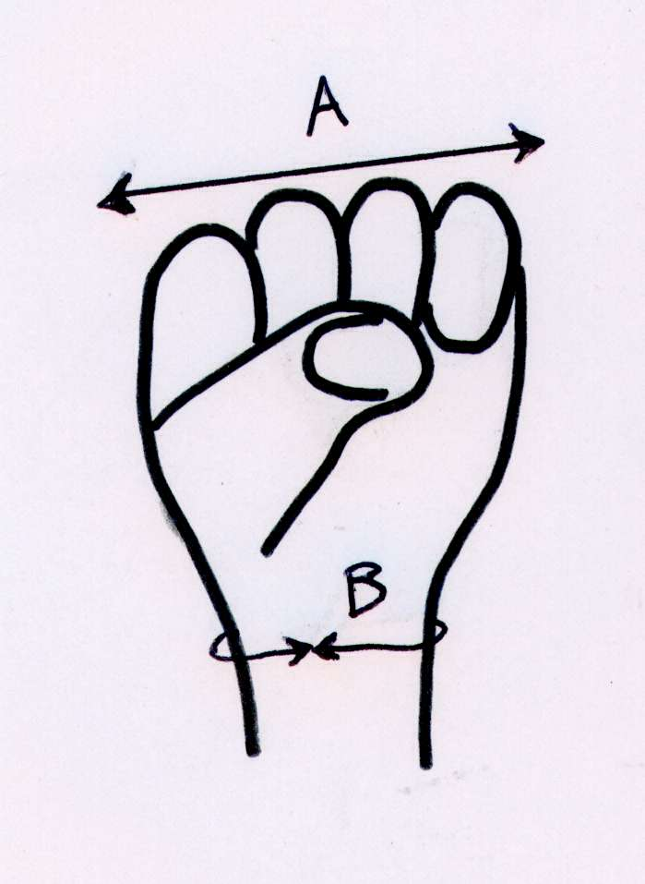
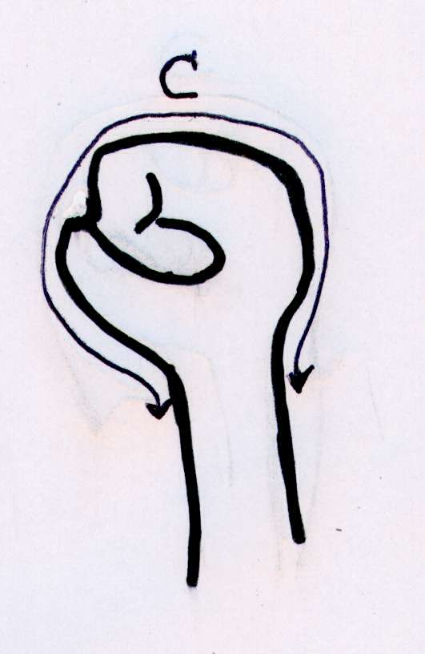
呎吋單位Measurement Unit: inch cm
訂製呎吋 Order 1
A: 拳頭寬度Width of Fist |  | A:
B: 手腕圓周 Circumference of Wrist |  | B:
C: 由手腕正面經拳頭頂至手腕背面From ventral wrist pass fist to dorsal wrist |  | C:
 | 數量 Quantity: 件 Piece(s)

